La Chute de la Maison Usher (The Fall of the House of Usher) (1928)
Thomas Patrick Pringle (McGill University)
La Chute de la Maison Usher [The Fall of the House of Usher, 1928] is an adaptation of Edgar Allen Poe’s eponymous story and the best-known film of French Impressionist director Jean Epstein. In the film, Roderick Usher spends his time painting his illness-stricken wife, Madeline, alone in their castle. When an unnamed friend of Usher visits, Madeline appears to die and is quickly buried, but she subsequently returns to life and destruction consumes the house. The film is heavily influenced by German expressionism, while also exemplifying some of Epstein’s most important formal contributions. Epstein was fascinated by cinematography’s proximity to human perception. In his theoretical writings on the concept of photogénie, he argued that film is uniquely capable of animating the material world by revealing sensibilities otherwise hidden. In one particularly atmospheric sequence in Usher, Epstein animates a funeral procession through double-exposure, slow motion, hand-held camerawork, and impressionist editing patterns. Epstein used these methods to endow objects with personalities, movement, and, in the film’s conclusion, a dangerous vitality. Surrealist Luis Buñuel worked on the film as an assistant to Epstein, but quit after a creative disagreement—setting the stage for Buñuel’s formal disavowal of Impressionist aesthetics with Un Chien Andalou (1929).
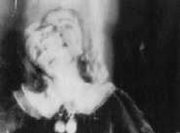 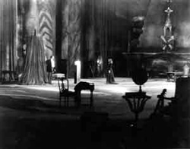
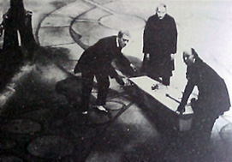
Image Source: http://sensesofcinema.com/2004/feature-articles/la_chute_de_la_maison_usher/
Cinematic animism and photogénie in the funeral procession:
http://www.youtube.com/watch?v=xH0aqW2x8po

References and Further Reading:
Aumont, Jacques, (Ed.) (1998) Jean Epstein: Cinéaste, Poète, Philosophe. Paris: Cinémathèque Française.
Barreiro, M.S. (2013). “Epstein’s The Fall of the House of Usher: Research on Altered States of Consciousness.” Literature Film Quarterly, 41.3:197-209.
Keller, S. and Paul, J. (Eds.) (2012) Jean Epstein: Critical Essays and New Translations. Amsterdam: Amsterdam UP.
Turvey, M. (2008) Doubting Vision: Film and the Revelationist Tradition. New York: Oxford UP.

